&
Santee Legend
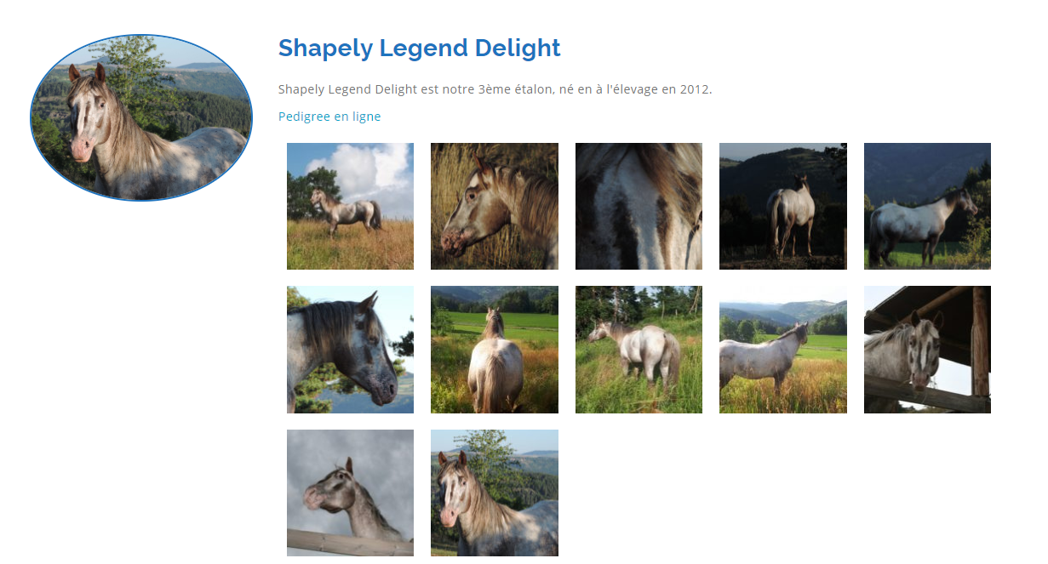
Santee Spanish Delight

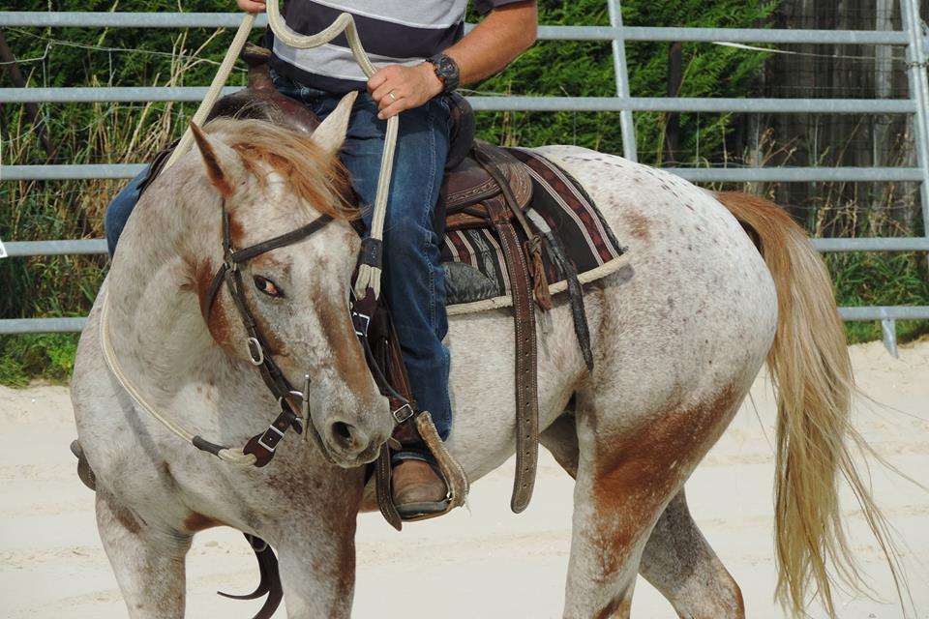
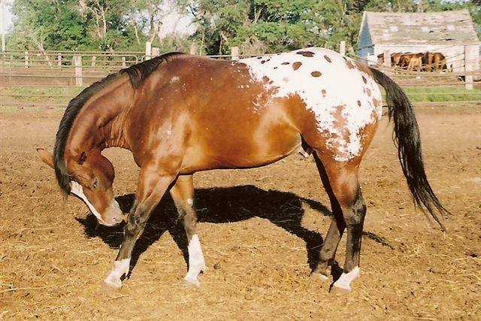

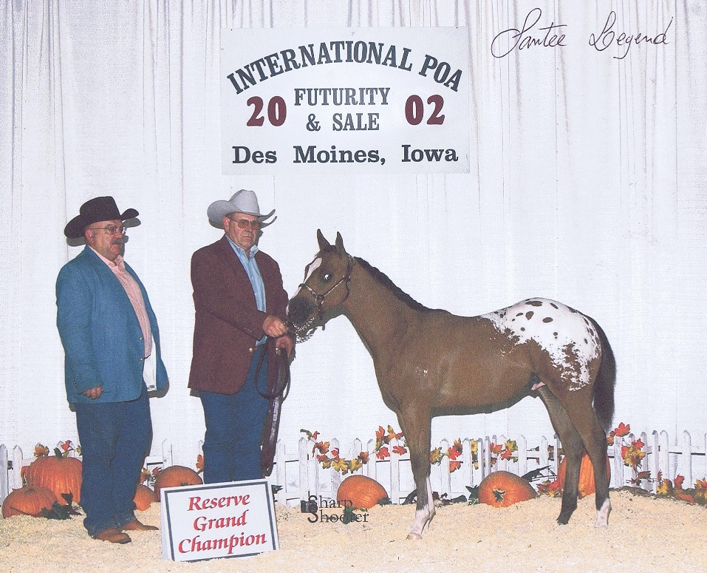
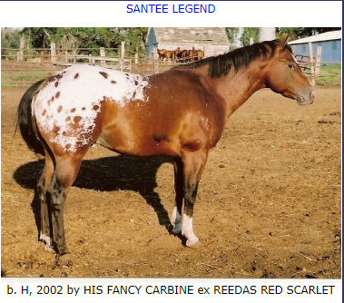

Fils de Santee Legend Reserve Grand Champion

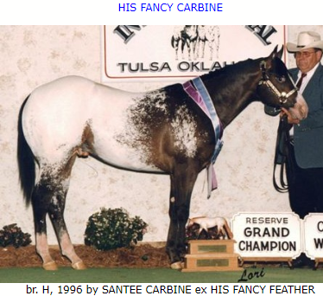
Par His Fancy Carbine Reserve Grand Champion

Petit Fils de Reedas Red Scarlet Cattle Performance with many AQHA Points

Par Oakie Red Jack

Petit Fils de Santee Spanish Nick Grand Champion an World Champion ship Show
International Champion
1500 points in Halter
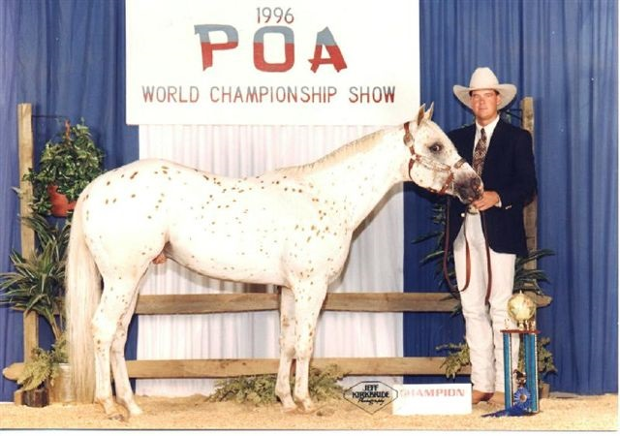
Et 1500 points in Riding Events

